WET-SORB
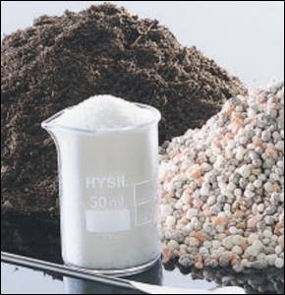
is a highly absorptive superabsorbent polymer (SAP)
with up to 700-fold higher water absorption capacity.
WET-SORB absorbs and retains the water effectively.
It releases the captured moisture as needed and
delivers it in controlled, targeted doses to the roots
as soon as the soil starts to dry out.

A SPLENDID SHOW OF FLOWERS,
A RICH GREEN, A HEALTHY CROP –
THAT IS WHAT
AMATEUR AND PROFESSIONAL
GARDENERS, LANDSCAPERS AND
AGRICULTURALISTS
LIKE TO SEE.

TO ACHIEVE THESE KIND OF
RESULTS, IT HELPS TO HAVE GREEN
FINGERS OR,
THOSE WHO NEED A MORE
INNOVATIVE SOLUTION:

WET-SORB, THE SOIL ADDITIVE.
MAKE SURE YOU DERIVE THE
BENEFITS OF WET-SORB FOR
YOUR SOIL:

* MORE EFFICIENT USE OF WATER

* LOWER IRRIGATION COSTS

* HIGHER YIELD

* ACCELERATED GROWTH.

W E T-S O R B : O n e s u p e r a b s o r b e n t , m u l t i p l e

WET-SORB is compatible with all soil types.
Amateur gardeners and professionals in landscaping, tree planting and Home & Garden

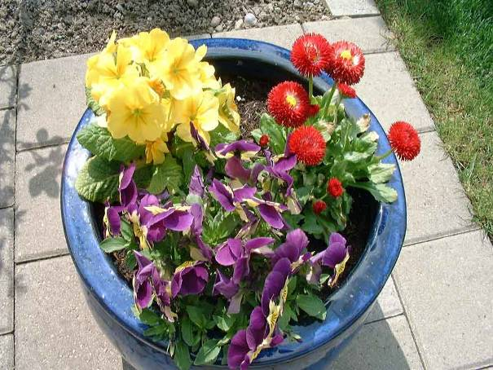
WET-SORB puts the bloom in hanging baskets and window boxes for a better show of flowers. The benefits are evident:
More flowers that bloom for longer
Flowers are more resistant to drought
Flowers last for longer periods without watering, reducing
water consumption by approx. 30%. Ideal for holidayers!
Minimises excessive water run-off and evaporative losses
Less fertilizer leaching
Better transportation of nutrients in the substrate

Tree Planting and Tree Nurseries

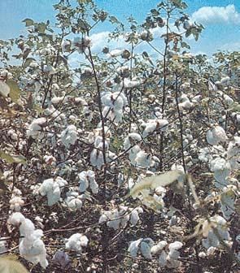
WET-SORB delivers just the right amount of water to the root system, offsets periods of drought and improves the aeration of the soil, resulting in better overall plant development. Specific benefits include:
Rapid germination and a well-developed root system
Increased germination rates and higher survival rates
A better uptake of nutrients
Higher biomass production
Shorter growth cycles
Compatible with poor and problem soils in arid regions

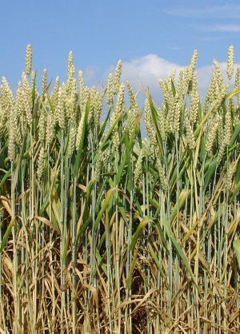

Professional vegetable and fruit production

Professional growers looking to improve their yields of high
value crops like tomatoes, lettuce, and strawberries stand to benefit from WET-SORB :
WET-SORB retains moisture in all soil types, including peat moss
Improves water-holding capacities in nursery bark chips, keeps water near the roots
More efficient use of fertilizer as leaching is prevented
Increased crop yield

A p p l i c a t i o n s .

many other areas look to WET-SORB for an efficient, sustainable and easy-to-use

moisture management solution.
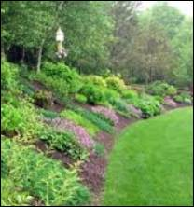

Landscaping

WET-SORB provides just the right amount of water to the root system, an important feature with benefits that professionals appreciate:
Well-developed root system with a better uptake of nutrients and higher biomass production
Shorter growth cycles
Less soil compacting
Better water uptake, reduced drought stress

Golf course construction


WET-SORB meets the highest golfing standards as a matter of course. Just apply WET-SORB in the root zone and enjoy benefits such as:
Rapid turf seed germination
Thicker, more durable turf with stronger, more developed root-system
Easily applied with standard equipment
Lower irrigation costs due to increased moisture content of the soil
Improved soil aeration and increased soil
porosity

Reforestation
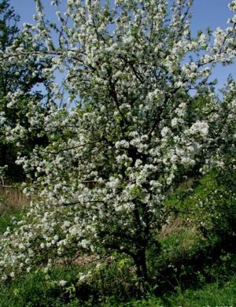

WET-SORB helps in reforesting and recultivating arid regions

to restore their usefulness. The benefits are:
Improved development of the root system
Rapid germination and higher survival rates
Improved water retention in the soil
Reduced irrigation frequency resulting in cost savings
Less water loss through drainage or evaporation
Nutrients can be easily taken up by the plants

How to apply WET-SORB

WET-SORB is suitable for blending with all soil types and meets the criteria for user-friendliness in all applications. It only takes a few steps:

Add WET-SORB to your soil.
Mix WET-SORB and the substrate thoroughly until you get a homogeneous blend
Plant or sow as usual
Irrigate immediately to allow WET-SORB to absorb the maximum amount of water

Greener and cleaner for forward looking growth

WET-SORB is long lasting thanks to the long- term stability typical of superabsorbents.
And that's what makes WET-SORB so efficient in all applications for amateur and professional gardeners.

WET-SORB not only helps make the world a greener place. It's also environmentally friendly and ecotoxicologically safe. Its biocompatibility makes it safe to compost, with no risk of harming the composting process.

Application rates for different plants

Trees and shrubs 50g/hole

Flowerbeds, borders,
nursery beds 2.5-3.0 g/l

Tubs, hanging baskets,
window boxes 2.5-3.0 g/l

Strawberries 2.5 g /m2

Tomatoes, peppers, lettuce 5 g /m2

Lawns 50 g /m2

Innovation for success that is sustainable

Our activities are compatible with the principles of sustainable development. That means, they are to satisfy the demands of contemporary generations while safeguarding those of generations to come. Commercial interests do not take priority over safety, the protection of health and the environment.

